Learning Circle Group : Places & Perspectives middle school – PPM2
Sponsoring Teacher : Khuzama AlMomani
Name of Project : Knowing You

Made by Olga Brodetskaya
1 - Your Favorite Quotes .
- write 6 of your favorite quotes .
- Actions speak louder than words
- Never stop learning because life never stops teaching
- You are never too old to set another goal or to dream a new dream. C. S. Lewis
- There is only one way to avoid criticism: do nothing, say nothing, and be nothing. Aristotle
- Mirror is my best friend, because when I cry it never laughs. Charlie Chaplin
- If you are brave enough to say goodbye, life will reward you with a new hello. Paulo Coehlo.
- name 3 quotes you strongly agree with . I agree with all the previous quotes.
- name 3 quotes you disagree with & WHY? I could find such quotes

2 - tell us about your favorite 5 places around the world , you can use maps , pictures , info ..etc.
I described 5 places which I visited myself.
Paris
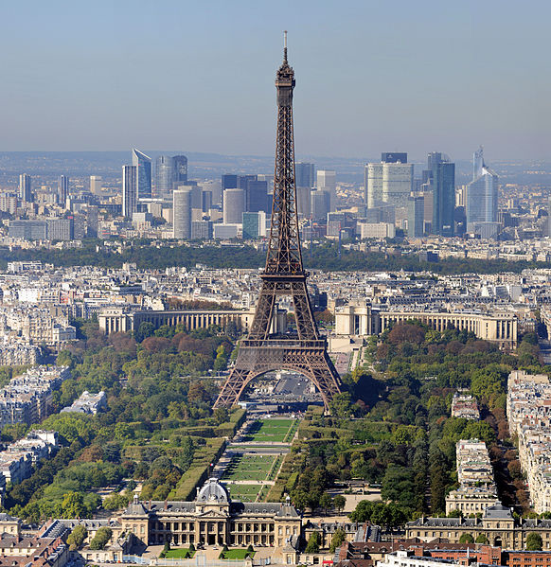

Paris, the cosmopolitan capital of France, is - with 2.2 million people living in the dense (105 km²) central city and almost 12 million people living in the whole metropolitan area - one of the largest agglomerations in Europe. Located in the north of the country on the river Seine, Paris has the reputation of being the most beautiful and romantic of all cities, brimming with historic associations and remaining vastly influential in the realms of culture, art, fashion, food and design. Dubbed the City of Light (la Ville Lumière) and Capital of Fashion, it is home to the world's finest and most luxurious fashion designers and cosmetics, such as Chanel No.5, Christian Dior, Yves Saint-Laurent, Guerlain, Lancôme, L'Oréal, Clarins, etc. A large part of the city, including the River Seine, is a UNESCO World Heritage Site. The city has the second highest number of Michelin-restaurants in the world (after Tokyo) and contains numerous iconic landmarks, such as the world's most visited tourist site the Eiffel Tower, the Arc de Triomphe, the Notre-Dame Cathedral, the Louvre Museum, Moulin Rouge, Lido etc, making it the most popular tourist destination in the world with 45 million tourists annually.

St.Petersburg
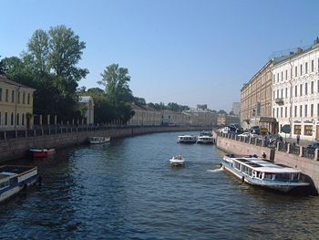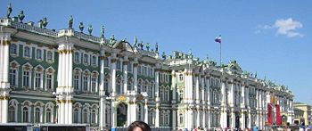
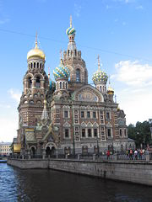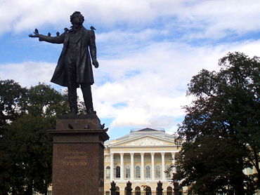
Saint Petersburg is a world-class destination and Russia's second largest city, with a population of 5 million (September 2012) perched at the eastern tip of of the Baltic Sea and the Neva River. The city was formerly known as Petrograd , and later Leningrad . UNESCO list the city among the top 10 destinations worldwide.

This is one of the most breathtakingly beautiful places on earth, and virtually any building in the large historic center, threaded with canals dotted with baroque bridges, can be considered an attraction—and indeed, it is a UNESCO World Heritage site. This is a magical city, with a long list of major attractions. Its Hermitage Museum, housed in the Winter Palace of the Romanov Dynasty, is both one of the world's greatest and oldest collections of art, treasure, and antiquities, and one of its most beautiful buildings.

Lago di Garda (Sirmione)

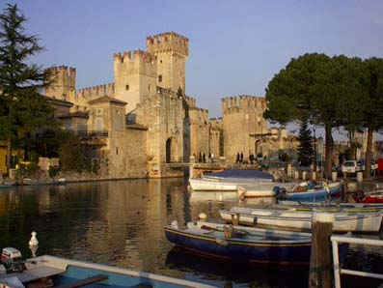
Sirmione is a comune in the province of Brescia, in Lombardy (northern Italy). It is bounded by the comunes of Desenzano del Garda (Lombardy) and Peschiera del Garda in the province of Verona and the region of Veneto. It has a historical centre which is located on the Sirmio peninsula that divides the lower part of Lake Garda.
Sirmione, spa and resort, spirit and culture, restaurants and refind discotheques, thermal baths and outstanding hotels, gastronomy and pizza, excellent wine, markets and fashion shops, the International Academy for Literature, Lunapark and Gardaland - a child's paradise - the meeting point of tradition and future....

Here one finds and meets others. Sirmione is simple and complex, young and old, full of life and movemeunt but also silent and contemplative, the Eldorado of water sports and a dreamy village in the twilight. Contrasts. Sirmione is like a fan with many slats, but it remains unique in its essence.
Sirmione - a forum for conferences and for exchanging ideas - a place for sports, active live, rest, a plece of wine, silence, culture. A symphony of leisure, tradition and health.
Sirmione where contrasts meet.....

Venice
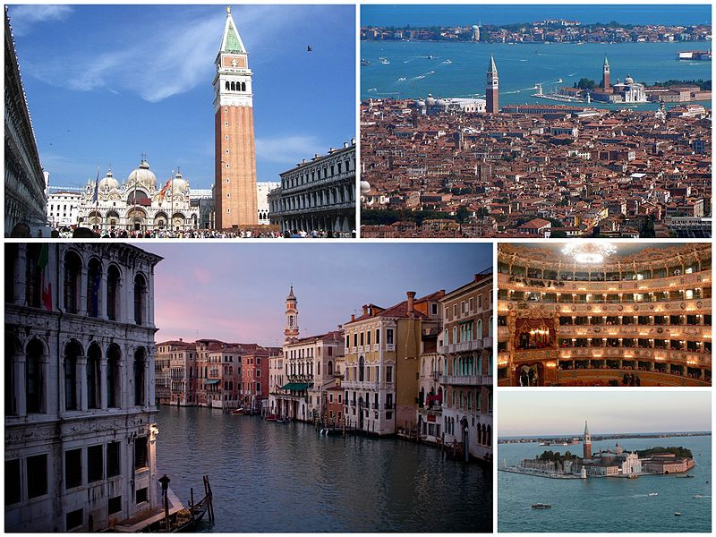
Venice (Italian: Venezia) is one of the most interesting and lovely places in the world. This sanctuary on a lagoon is virtually the same as it was six hundred years ago, which adds to the fascinating character. Venice has decayed since its heyday and is heavily touristed (there are slightly more tourists than residents), but the romantic charm remains.

Barcelona
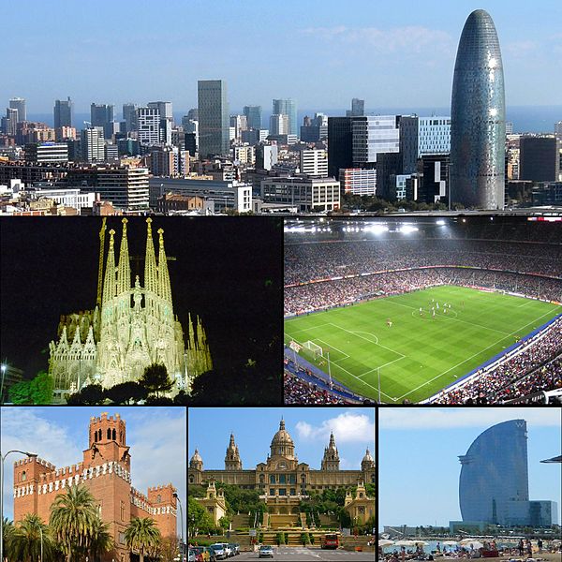

Barcelona is the capital of Catalonia and the second largest city in Spain, after Madrid, with a population of 1,620,943[1] within its administrative limits on a land area of 101.4 km2 (39 sq mi).

Founded as a Roman city, Barcelona became the capital of the County of Barcelona. After merging with the Kingdom of Aragon, Barcelona became the most important city of the Crown of Aragon. Besieged several times during its history, Barcelona has a rich cultural heritage and is today an important cultural centre and a major tourist destination. Particularly renowned are the architectural works of Antoni Gaudí and Lluís Domènech i Montaner, which have been designated UNESCO World Heritage Sites. The headquarters of the Union for the Mediterranean is located in Barcelona. The city is known for hosting the 1992 Summer Olympics as well as world-class conferences and expositions and also many international sport tournaments.

Barcelona is today one of the world's leading tourist, economic, trade fair/exhibitions and cultural-sports centres, and its influence in commerce, education, entertainment, media, fashion, science, and the arts all contribute to its status as one of the world's major global cities

3 - Name 3 of your favorite books , write the name of the book , the writer , & try to summarize the book , or write the main ideas in few lines .

4 – if I asked you to name 5 people from any field ( politics, art , ..etc ) that you would like to have dinner with & why ? no matter those people are dead or alive .
Yury Gagarin
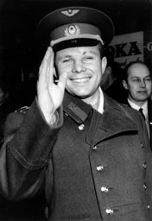Yuri Alekseyevich; 9 March 1934 – 27 March 1968) was a Soviet pilot and cosmonaut. He was the first human to journey into outer space, when his Vostok spacecraft completed an orbit of the Earth on 12 April 1961.

Antonio Gaudi
The work of Antoni Gaudí represents an exceptional and outstanding creative contribution to the development of architecture and building technology in the late 19th and early 20th centuries.
. 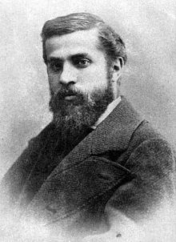 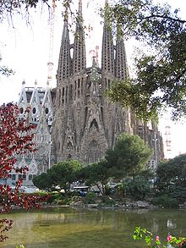 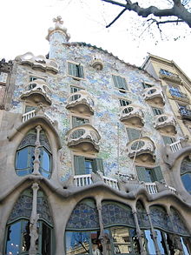
Gaudí's works reflect his highly individual and distinctive style and are largely concentrated in the Catalan capital of Barcelona, notably his magnum opus, the Sagrada Família

William Shakespeare
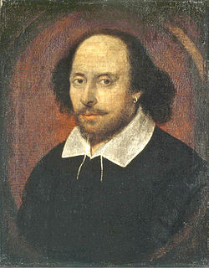

William Shakespeare (26 April 1564 (baptised) – 23 April 1616was an English poet and playwright, widely regarded as the greatest writer in the English language and the world's pre-eminent dramatist. He is often called England's national poet and the "Bard of Avon".[2][nb 2] His extant works, including some collaborations, consist of about 38 plays, 154 sonnets, two long narrative poems, two epitaphs on a man named John Combe, one epitaph on Elias James, and several other poems. His plays have been translated into every major living language and are performed more often than those of any other playwright.

Agatha Christie
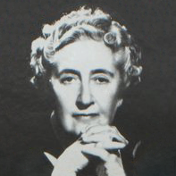
Dame Agatha Mary Clarissa Christie, DBE (née Miller; 15 September 1890 – 12 January 1976) was a British crime writer of novels, short stories, and plays. She also wrote six romances under the name Mary Westmacott, but she is best remembered for the 66 detective novels and more than 15 short story collections she wrote under her own name, most of which revolve around the investigations of such characters as Hercule Poirot, Miss Jane Marple and Tommy and Tuppence. She also wrote the world's longest-running play The Mousetrap.
According to the Guinness Book of World Records, Christie is the best-selling novelist of all time. Her novels have sold roughly 4 billion copies, and her estate claims that her works rank third, after those of William Shakespeare and the Bible, as the world's most widely published books.

Leonardo da Vinci
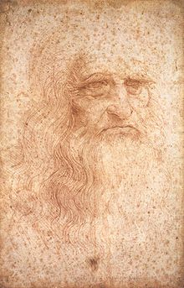
Leonardo di ser Piero da Vinci (April 15, 1452 – May 2, 1519, Old Style) was an Italian Renaissance polymath: painter, sculptor, architect, musician, mathematician, engineer, inventor, anatomist, geologist, cartographer, botanist, and writer. His genius, perhaps more than that of any other figure, epitomized the Renaissance humanist ideal. Leonardo has often been described as the archetype of the Renaissance Man, a man of "unquenchable curiosity" and "feverishly inventive imagination".He is widely considered to be one of the greatest painters of all time and perhaps the most diversely talented person ever to have lived. According to art historian Helen Gardner, the scope and depth of his interests were without precedent and "his mind and personality seem to us superhuman, the man himself mysterious and remote". Marco Rosci states that while there is much speculation about Leonardo, his vision of the world is essentially logical rather than mysterious, and that the empirical methods he employed were unusual for his time.

