Endangered Species
Endangered Birds
Red Knot: Is a bird that journeys from the southern tip of South America and then rests on the Delaware Bay. After the long journey they are very slim so while on the Delaware Bay they gorge on Horseshoe crab eggs. During breeding season their breasts turn a rusty red. The Birds come to New Jersey during May through August. The Red Knots usually stay around the beach. The population is steadily decreasing as the horseshoe crab population shrinks. 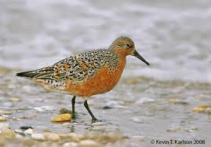

Humpback Whale
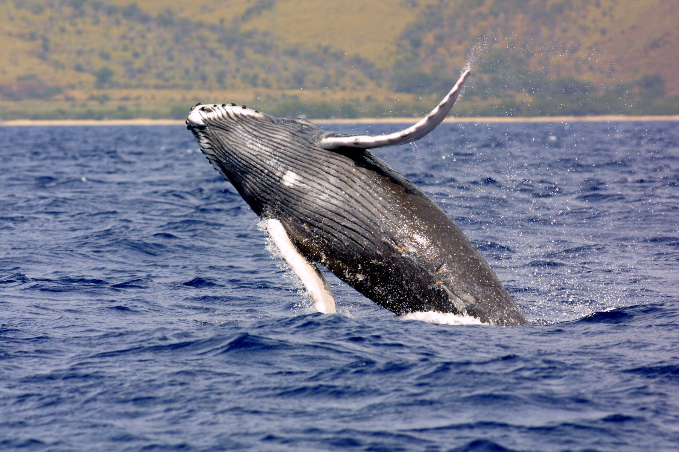
These whales usually reach a length of 16.2 long and their bellies are white. In North America there fins are white. There baleen plates are black with an olive color. The most distinctive feature is there long fins that are 1/3 their body length and this is how scientists track their position. Also they have a hump 2/3 ways down.

http://www.nj.gov/dep/fgw/ensp/pdf/end-thrtened/whales.pdf

American Burying Beetle
The adult Burying Beetle can range from 1.0 to 1.5 in length. Its color is orange and red on shiny black. Males have large distinctive orange-red rectangular facial mark. The females have a triangular mark. They live in the grasslands or scrubs or in oak-hickory forests. They are active at night. They were listed endangered in 1989.
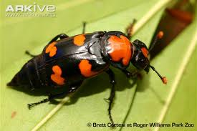
http://www.nj.gov/dep/fgw/ensp/pdf/end-thrtened/amburyingbtl.pdf

Timber Rattle snake
This is one of 2 poisnus

