The bald eagle is the bird of the United States and can be found in the forests of New Jersey. The bald eagle is thirty-five to thirty-seven inches tall. Their wing span is seventy-two to ninety inches and they weigh from ten to fourteen pounds. The bald eagle lives in its nest in the trees of the New Jersey forests. The bald eagle is also a strong swimmer and nests near rivers and coasts. The bald Eagle eats mainly fish, but they also take advantage of decaying flesh. The bald eagles once paired remain together until one dies. The bald eagle molts in patches and takes almost half a year to molt.
As a result of the use of the pesticide DDT, the number of nesting pairs of bald eagles in the state declined to only one by 1970 and remained at one into the early 1980’s.Since the use of DDT was banned the number of young eagles has increased drastically. They also released sixty young eagles. The amount of young bald eagles in 2012 was one hundred sixty-five and the number of nests is one hundred twenty.

Source of information:
www.nj.gov/dep/fgw/ensp/pdf/end-thrtened/baldeagle.pdf
source of pictures:

http://www.designeau.com/bald-eagle-wallpaper-10909-hd-wallpapers.htm
http://heatherlindayoung.wordpress.com/2010/12/22/follicly-challenged-birds-of-prey/
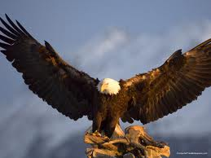
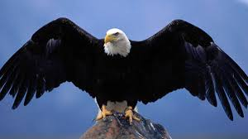
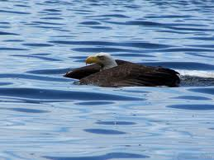
http://alaskasphotos.com/main.php/v/alaska-collections/bald-eagle swimming/100_0183.jpg.html

