By Miguel Sosa ^u^
My 3 favorite quotes…
- “Change will not come if we wait for some other person or some other time. We are the ones we've been waiting for. We are the change that we seek,” Barack Obama.

- “The best and most beautiful things in the world cannot be seen or even touched - they must be felt with the heart,” Helen Keller.
- “Education is the most powerful weapon which you can use to change the world,” Nelson Mandela.
3 quotes I disagree with…
- “I don't think I've got bad taste. I've got no taste,” Graham Norton
- “Bad taste creates many more millionaires than good taste,” Charles Bukowski.
- “To achieve harmony in bad taste is the height of elegance,” Jean Genet

I disagree with these quotes because they don’t really spark or move me. I believe this because in my opinion they’re meaningless. They have no significance to me.

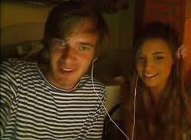
5 people who I would have dinner with…
- PewDiePie (Felix Kjellberg) + CutiePieMarzia (Marzia Bisognin)
- Smosh (Anthony Padilla + Ian Hecox)
- Taylor Swift
- Shigeru Miyamoto (Father of Mario)
- Kazuki Takahashi (Creator of Yu-Gi-Oh!)

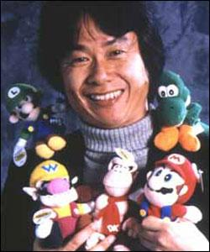
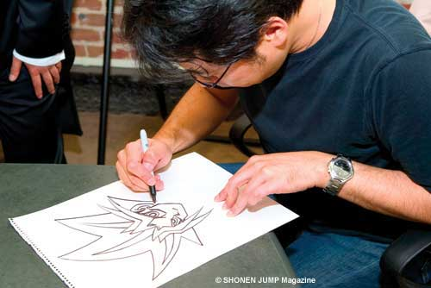

I would have dinner with Felix and Marzia because they are really funny. Every time I go on YouTube and watch their videos, I always end up laughing or smiling. Felix makes videos of let’s plays, which means he plays video games and commentates while playing. Marzia does a variety but she mainly focuses on makeup and things like that. They can sometimes be found in each other’s videos because they happen to be dating.
I would have dinner with Smosh because they like Felix and Marzia are also funny. They usually make funny videos on YouTube. If you want to see them play like Felix does, you can go to their channel “Smosh Games.” You can find Felix in their videos too, they are close friends.
I would have dinner with Taylor Swift because she is an amazing artist. I love her songs very much. My favorite song is, “I Knew You Were Trouble.” I really appreciate all her music. I would have dinner every day with her if I could. She’s just that famous and awesome!
I would have dinner with Shigeru Miyamoto because he’s the father of Mario! Mario is one of my all time favorite games. If you ask my friends they will tell you I’m in love with that game. For me it’d be an honor to eat dinner with him. He is great at what he does, without him and Mario, gaming would really stink. Everyone loves Mario!!!
I would have dinner with Kazuki Takahashi because he is the creator of one of my many favorite shows. He created Yu-Gi-Oh! It’s a very awesome TV show where people battle with duel monsters in cards. Maybe he could teach me how to draw like him and make my own TV shows one day.

My 5 favorite places in the world…
- Japan
- Korea
- China
- Ireland
- Dominican Republic
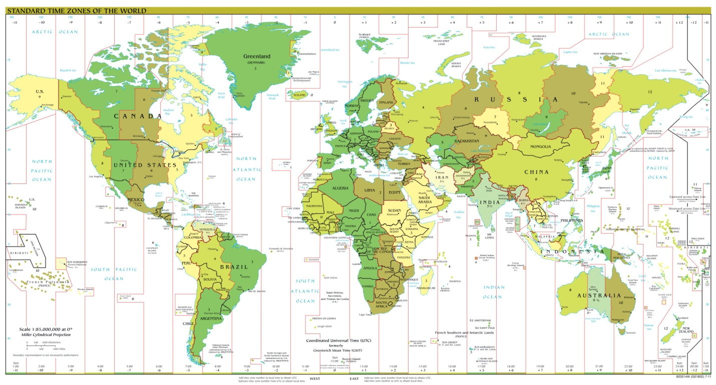

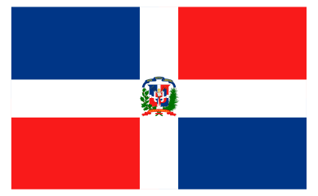
Korea and Japan are two of my favorite places in the world because they are the home of a type of music I like. It’s really catchy and I love the songs. My favorite bands are 4 Minute and Girls Generation. I also like Japan because they make a lot of Animes and Mangas there.
I chose Dominican Republic because that’s where my family is from.
Ireland is where one of my really good friends lives. I picked that for her since that is where she is from.
I like China because they do the same thing Japan does, but they don’t do so much of it.

Sources for images:
www.fanpop.com
http://chibiyami-chan.blogspot.com/2011/05/mangakas.html
mysterious-master-x.deviantart.co
http://www.glogster.com/natt201/smosh/g-6m0pfr02h4prumvlccukga0
http://linkrandom.blogspot.com/2011/03/people-i-like-shigeru-miyamoto.html
http://commons.wikimedia.org/wiki/File:World_Time_Zones_Map.png
http://search.whatbestdegree.com/search.php
http://4photos.net/blog/dominican-republic-island-pictures/
http://itendtobabble.com/2012/11/01/piece-of-k-pop-girls-generation-flower-power/
http://www.fanpop.com/clubs/chinese-food/images/24147606/title/sesame-chicken-photo

