Our favorite quotes:
- “Life is the art of drawing without an eraser.”- John W. Gardner
We love this quote because it is so true. You cannot erase the past. I think of it as living with no regrets.
- “Love is Life”- Isabella Lyons
This quote is dear to my heart because having love in my life means everything to me like my family and friends. Literally without love I don’t see a life for me.
- “Wheresoever you go, go with all your heart.”- Confucius
This quote is our favorite because you should always have your heart open wherever you go. If you don’t, you will be lost.
- “The only thing we have to fear is fear itself.”- Franklin Delano Roosevelt
We love this quote because you shouldn’t be afraid at all. You shouldn’t live in fear.
- “There is a kind of beauty in imperfection.”-Conrad Hall
This is all there is to it. Beauty isn’t plastic. It is you. To be perfect isn’t beautiful. So many magazines commercialize to be perfect but that isn’t true beauty. True beauty is within.
- “Justice cannot be for one side alone, but must be for both.”- Eleanor Roosevelt
This final quote is how all life should be. Justice is two sided. All voices should be heard.
Quotes we strongly agree with:
- “Nonviolence is a powerful and just weapon which cuts without wounding and ennobles the man who wields it. It is a sword that heals.”-Martin Luther King, Jr.
We strongly agree with this quote because violence is not the answer. Nonviolence has as much effect as violence.
- “Truth is powerful and it prevails.”-Sojourner Truth

We agree with this quote because speaking the truth is a big part of life. A lie doesn’t last forever but the truth does.
- “The world's biggest power is the youth and beauty of a woman.”-Chanakya
Lastly we agree with this quote because being young and a woman is beautiful. Never doubt it.

Quotes we strongly disagree with:

- "No, I don't know that atheists should be considered as citizens, nor should they be considered patriots. This is one nation under God."-George Bush

We don’t believe in this quote because everybody is equal and they should be treated equally in America.

- “If I like a food, I'll eat it, even if I know it's not good for me.”- Kim Kardashian

We don’t agree with this quote because why does it matter what you eat? In the end it really doesn’t it matters what is on the inside.

- “All British people have plain names, and that works pretty well over there.”- Paris Hilton

We don’t agree with this quote because it is so stereotypical. She was not thinking when she said this.
Our favorite places around the world:
- Dominican Republic
- Bora Bora
- Paris
- Fiji
- Ireland

- The first person we would have dinner with is Audrey Hepburn. Audrey Hepburn was an actress who is dead now. She was famous in her movie Breakfast at Tiffany’s. We would have dinner with her because she is so amazing. She is a fashion icon and she was pure elegance.

- We would also have dinner with One Direction. One Direction is a famous boy band who are all British except for one who is Irish. There are 5 boys in all who are named Harry, Niall, Zayn, Liam, and Louis. We are big fans of their music and they are so inspirational. Also they are very cute.

- We would also have dinner with Justin Timberlake. This is because he is such a great singer. He always seems to come out on top. Though he took a break he has come out with two great songs called Mirrors and Suit and Tie.

- Anne Frank is somebody we would have dinner with because she was hiding from the Nazis because she was Jewish. She kept a journal and she was very courageous and we commend her for it.

- Sean O’Donnell has to have dinner with us. He is a Hollister model who is so cute. We relate to each other so much. We were both born in New York and we both love eating.

Fiji 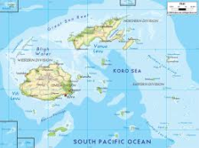Fiji location
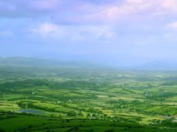Ireland
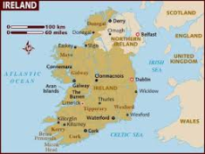Ireland location
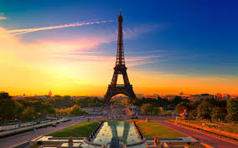Paris
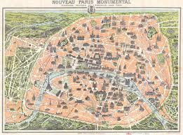Paris location
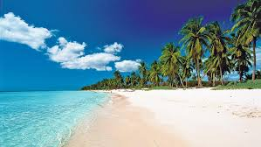Dominican Republic
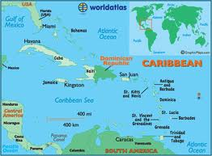Dominican Republic location
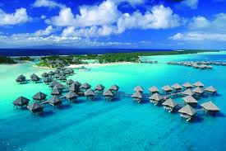Bora Bora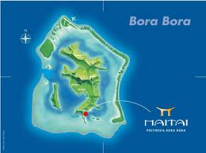Bora Bora location
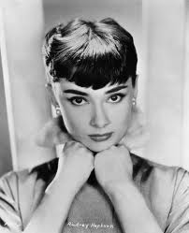Audrey Hepburn
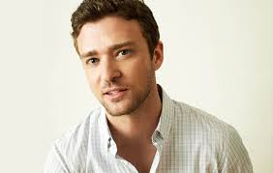Justin Timberlake
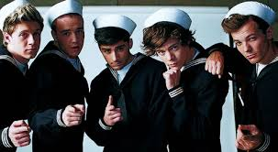One Direction
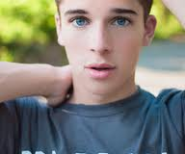Sean O’Donnell
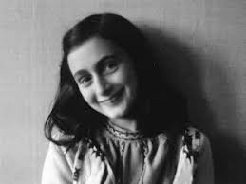Anne Frank

