Regular School Day
At the Scarborough Middle School, the school day starts at 7:45 AM. Every other Wednesday, we have a “late start day.” Late start days start at 9:00 AM. We have eight periods a day not including lunch. We get out of school at 2:10 PM. In homeroom (before the school day starts) there are club meetings and something called “morning band.” Here at SMS, we have many clubs to choose from, however not all of them meet in the morning. Some are after school. Morning band is for students who take band class. During morning band we practice our concert music. We also have school sports. Scarborough Middle School offers soccer, lacrosse, basketball, track, wrestling, field hockey, cross country and cheering.

Regular Day
The everyday middle school student wakes up to their alarm clock at around 6:00-6:30 AM. They then get up, stretch and then head down stairs for breakfast. Breakfast usually consist of muffins, waffles, pancakes, breakfast sandwiches or milk and cereal. The student will then get dressed and pack up for school. He/she will proceed to their bus stop. Waiting at the bus stop takes about five to ten minutes. However, some kids get driven to school.
Most buses have middle schoolers and high schoolers. The high schoolers get dropped off first at the Scarborough High School which is up a big hill away from the middle school.
Once you get to school, you get a small time before homeroom. During this time you can walk around school, talk with friends or do last minute homework. The free time ends when a teacher tells you to report to homeroom. Homeroom is known most famously for students doing last minute homework. Every Monday and Friday the school news is shown on the classroom television. The news is about ten too twenty minutes. Then finally the school day starts. You will start with going to period one. There are eight periods a day, not including lunch. You have two specials a day. These specials could be gym, foreign language, music/band, art, FLEX (study hall), sTem (science, technology, engineering and math), health, and computer.
We have afternoon homeroom, it starts at 2:10 when the announcements start. We all proceed to our homerooms, where we gather our books and backpacks and bring them into our class room. It depends for the quarter which grade leaves for the bus first. This is how it works: Quarter 1 6th graders, quarter 2 7th graders, quarter 3 8th graders and quarter 4 8th graders. THEN YOU GO HOME TO YOUR LOVELY PARENTS WHO LOVE YOU SO MUCH AND WANT YOU TO BE HOME. Most people have sports and do homework when they get home. This is how a regular day in the town of Scarborough goes.

The Food of Scarborough, Maine

-Pizza

-Spaghetti




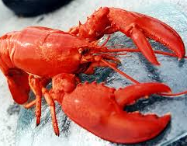


-Sandwiches

-Lobster

-Fish

-Seafood

-Steak

-Burgers




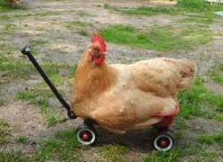


-Chicken

-Eggs

-Pork

-Ice Cream/Desserts

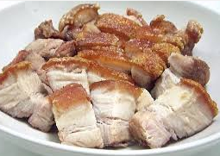








-French fries

-Tacos

-Chinese Food

-Turkey


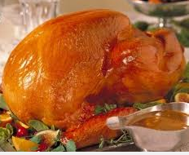



-Fruits

-Vegetables

-Salad

-Hot dogs

-Barbecue

-Chips

Traditions that Affect Our Daily Lives
We go to school



We have sports after school
We watch TV
We do homework
We have 3 meals a day
Religion/ church on the weekends

Goals, Hopes and Dreams
Julia~Goals: To be happy
Dream: To be successful
Hope: Go to college and get a good education

David M~Goals: Start a family
Dream: To be successful
Hope: Go to college

Jack~Goals: Become a doctor
Dream: To be successful
Hope: Go to college

Collin~Goals: Be successful
Dream: Have a family
Hope: Go to good college

Amelia~Goals: Start a family
Dream: Go to good college
Hope: Work in a hospital

Anna~Goals: Be successful
Dream: Go to college
Hope: Be a veterinarian

